C:\Documents and Settings\Jianhua Jiang\Desktop\1_副本.jpg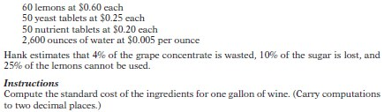

C:\Documents and Settings\Jianhua Jiang\Desktop\1_副本.jpg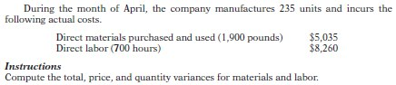

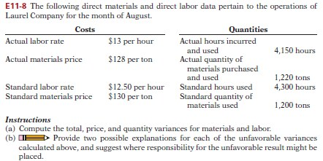

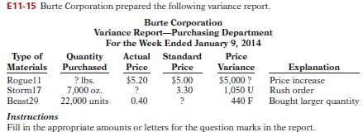

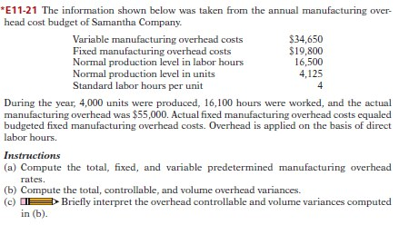

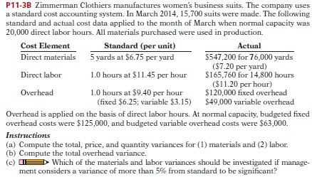

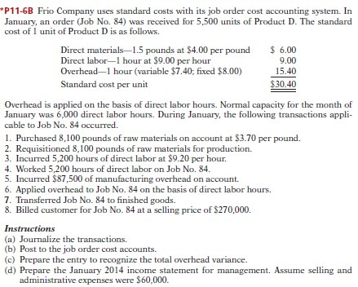

C:\Documents and Settings\Jianhua Jiang\Desktop\1_副本.jpg